Project plan
Brainwaves
Wouter Boendermaker
Eindhoven

Date | 19-12-2023
Version | 1.0
State | Unpublished
Authors | Sicong Nie, Omar Abdin, Sander Theeuwen, Atanas Georgiev, Jelmer de Rooij

Table of content
Revision history 4
Distribution 4
Context 5
Goal of the project 5
Assignment 5
Scope 5
Preconditions 5
Strategy 5
Research questions 5
End products 6
Project organization 7
Stakeholders and team members 7
Communication 7
Activities and time plan 8
Phases of the project 8
Time plan and milestones 8
Testing strategy and configuration management 9
Testing strategy 9
Test environment and required resources 9
Configuration management 9
Finances and risks 10
Project budget 10
Risks and mitigation 10

Contents
Table of content 2
Revision history 4
Distribution 4
Project assignment 5
Context 5
Goal of the project 5
Assignment 5
Scope 5
Preconditions 6
Strategy 6
End products 6
A) Research documents 6
B) Prototypes 6
C) One page game design documents 6
D) Test reports 6
Project organization 6
Stakeholders and team members 6
Communication 7
Activities and time plan 8
Phases of the project 8
Time plan and milestones 8
Testing strategy and configuration management 9
Testing strategy 9
Configuration management 9
Finances and risks 10
Project budget 10
Risks and mitigation 10
Literature list 11

Revision history
Version | Date | Authors | Changes | State
0.1 | 24-11-2023 | Lucas Mols | Added “Context”.  Added “Goal of the project”.  Added “Assignment”.  Added “Scope”.  Added “Preconditions”.  Started “Strategy”. | Unpublished
1.0 | 19-12-2023 | Sander Theeuwen | Updated “Context”.  Updated “Goal of the project”.  Updated “Assignment”.  Updated “Scope”.  Updated “Preconditions”.  Finished “Strategy”.  Added “End products” A, B, C, and D.  Added “Stakeholders and team members”.  Added “Communication”.  Added “Phases of the project”.  Added “Time plan and milestones”.  Added “Testing strategy”.  Added “Configuration management”.  Added “Project budget”.  Added “Risks and mitigation”.  Added “Literature list”. | Unpublished

Distribution
Version | Date | Receivers

Project assignment

Context
The clients for this project are Wouter Boendermaker and Veerle Shepers. Having experience with EEG and serious gaming, the project started with the statement “maybe it is fun to control a game character with your mind”. Recently, EEG has grown bigger, reaching the point where it can be implemented into games that originally do not support EEG control, (Nolan, 2023).

Goal of the project
The project is a research project, where documentation and research are the most valuable deliverables. The main research question is whether or not it is possible to use the Crown as input for games that are specifically designed to be controlled by brainwaves. The target group for this project is people who are paralyzed, who are unable to play games with regular controllers. In the desired situation, the player can use the EEG to play games without the need of assistance. By having games specifically designed for this target group, the project will bring more happiness to their lives.

The clients want the team to make a game that can be played by people that are paralyzed and unable to play games with a regular controller. The available device at Fontys, the Crown, which is an EEG, must be pushed to the limits to see what is possible. This project is a research project, where documentation and research are the most valuable deliverables.

Assignment
The project will consist of multiple prototypes as proofs of concept and research documents that contain all the findings, successful and unsuccessful. As research is the main focus of the project, the task for the team is to push the EEG provided by Fontys, the Crown, to its limits. The team needs to figure out what the device can do, what the weaknesses and strengths lie in the device, and come up with creative solutions to integrate these strengths into small games.

Scope
Inside scope | Outside scope
Prototypes of the games that show the device’s possibilities. | Fully polished games.
Research document(s) containing all the findings of the teams, focused on proofs of concept.

Preconditions
The clients target group is paralyzed people, unable to play games with regular controllers. The team will be using the EEG device provided by Fontys, the Crown, from Neurosity.
Git will be used using https://projects.fhict.nl/, which was a constraint given by Fontys.

Strategy
The team will be using Scrum, as the project is focused around rapid prototyping and research. Using Scrum, the development and research can be done in a flexible manner, where setbacks and breakthroughs can be taken into account.

End products

A) Research documents
The most important part of the project, the research documents, show all the findings of the team on EEG and the implementation of EEG.

B) Prototypes
The prototypes show multiple proofs of concept throughout the project. A feature of the Crown might work or not work, and these prototypes, in combination with their test reports, will explain why.

C) One page game design documents
These documents contain the design of the games. This will be high-level, as the games will not be very big or polished. The team did not deem it necessary to include ten page game design documents because of this reason.

D) Test reports
When a prototype is being developed or finished, or when research needs verification, test reports will be made to document what the players experience. Separating these results helps in the structure of the project.

Project organization

Stakeholders and team members
Name | Abbreviation | Role and functions | Availability
Atanas Georgiev |  | Git manager  Programmer
Jelmer de Rooi |  | Scrum master  Lead sound design  Programmer
Lucas Mols |  | Contact person  Programmer | Monday: 9.00  15:00  Tuesday: 9.00  15.00  Wednesday: 9.00  16.00  Thursday: 9.00  16.00  Friday: 9.00  15.00  Saturday: X  Sunday: X
Omar Abdin |  | Lead VFX  Programmer
Sander Theeuwen  s.theeuwen@student.fontys.nl  +31 6 10433821 |  | Note Taker  Lead Sound Design  Programmer | Monday: 8.00  23.00  Tuesday: 8.00  23.00  Wednesday: 8.00  17.00  Thursday: 8.00  23.00  Friday: 8.00  23.00  Saturday: 8.00  23.00  Sunday: 8.00  23.00
Sicong Nie  420648@student.fonty.nl  +31 6 33148891 | SN | Scene manager  Lead designer  Programmer | Monday: 8.00  23.00  Tuesday: 8.00  23.00  Wednesday: 8.00  17.00  Thursday: 8.00  23.00  Friday: 8.00  23.00
Wouter Boendermaker  w.boendermaker@fontys.nl |  | Stakeholder
Veerle Schepers  v.schepers@fontys.nl |  | Stakeholder

Communication
Discord is the main tool of internal communication. The team will communicate here when working online, as well as update the rest of the team after each workday with visual updates. As Tuesdays and Thursdays are days when the team works online, the standups will happen in the dedicated voice channel in Discord.
Meetings with the clients and experts will primarily be held in person, with MS Teams as an alternative if the meeting is urgent.

The team will have standups every workday.
When a sprint ends, a retrospective and task creation / division will be done as soon as possible, and will always occur on location.
Mr. Boendermaker will be briefed on a weekly basis, with the end of the sprints being a more formal meeting.

Activities and time plan

Phases of the project
The project will start by orientation and the setup of the project. Afterwards, the phases will solely be prototyping and researching. The team will conduct research about the features of the device while prototyping and getting the features to work in small games.

Time plan and milestones
Phasing | Start date | Finish date
Sprint 0: Setup | 27-11-2023 | 01-12-2023
Sprint 1: Orientation | 04-12-2023 | 15-12-2023
Sprint 2: Research / prototyping | 18-12-2023 | 22-12-2023
Sprint 3: Research / prototyping | 08-01-2024 | 19-12-2024

Testing strategy and configuration management

Testing strategy
The testing of the prototypes and theories consist of user tests only, as the prototypes are small to leave out technical tests and user feedback is the most important. The tests will be performed to verify theories, gather information about what parts of the device can be used and for what purpose, and to verify the quality of the prototypes.

Configuration management
The team will be using for code storage and management Git on https://projects.fhict.nl/ as described in the preconditions. Documents will be stored in Google Drive, so the team can access them from any device. Jira will be the tool for process management for close collaboration and access from any device. Discord is used to communicate internally, as it is fast and flexible. MS Teams is the preferred tool for online meetings with external people.

The git repository contains a main branch for releases, a dev branch for stable versions of the project, personal branches to have an overview of who is working on which feature, with underlying feature branches to keep code separated by feature. This is shown in Figure 1.
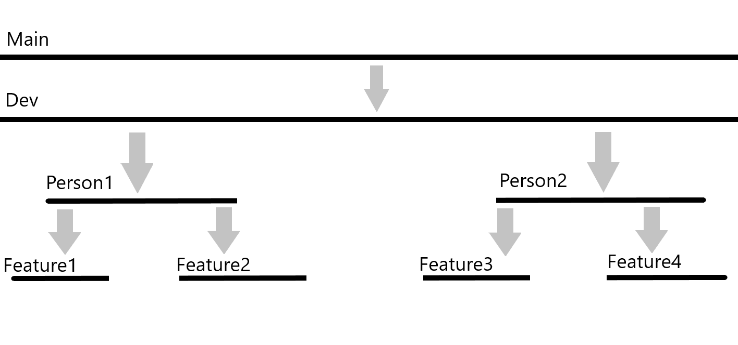
Figure 1: Git branching strategy.

Finances and risks

Project budget
No budget is indicated for this project, and the team is not planning on purchases. Should the need arise, the clients will be informed. The purchase will be researched (other available products etc.) and the final decision will be made in collaboration with the clients.

Risks and mitigation
Risk | Prevention activities | Mitigation activities
Team members falling ill. | - | Continue development. The ill team member will work from home if possible. The client will be informed if the illness impacts the productivity of the team.
Clients falling ill. | - | The other client will be contacted. If both fall ill at the same time, the semester coaches will be contacted who will provide guidance.
The Crown malfunctions. | The team members periodically run manual tests to see if the device still operates as expected. | Any anomalies will be reported within the team. The clients will be informed. Should the device be rendered inoperable, the ISSD will be contacted to request a second Crown.
The git environment malfunctions. | Team members will periodically pull from both the main and dev branches to keep the most recent changes locally. | The team member with the latest version of the project regarding the main and dev branch will push their repository to an alternative version manager.
The Google Drive environment malfunctions. | Documents will be downloaded periodically as a backup. | The backup documents will be uploaded to an alternative cloud storage.
Research shows the Crown is not optimal for gaming purposes. | - | The group will still focus on the capabilities of the Crown, as well as making a suggestion in the respective research document that other devices may work better. The client will be updated about the discovery.

Literature list
Nolan, M. (2023, May 24). This mindful gamer Out-Thought Elden ring. IEEE Spectrum. Retrieved December 19, 2023, from https://spectrum.ieee.org/elden-ring-hands-free-controller.

